DATA ANALYSIS PROJECT
ANALYZING 25 YEARS OF GLOBAL TOURISM: RECEIPTS, ARRIVALS, AND GDP CONTRIBUTION

SUBMITTED BY
DHAKSHINAMOORTHY M
EMAIL: mdhakshinamoorthy1@gmail.com

CONTENTS
- Introduction
- Objectives of the Analysis
- Data Collection
- Data Inspection/Initial Analysis
- Data Cleaning and Transformation
- Exploratory Data Analysis
- Visualization
- Technologies Used.
- Insights Generation 10. Conclusion

Tools & Technologies Used

Category | Tool / Library | Purpose & Usage
Data Handling | Pandas | Data cleaning, transformation,  grouping, KPI  calculation
Numerical Analysis | NumPy | Array operations, scaling, and numerical computations
Visualization | Matplotlib | Line charts, scatter plots, KDE plots, static visual storytelling
 | Seaborn | Correlation heatmaps and enhanced  statistical visuals
 | Plotly Express | Interactive charts: choropleths,  dropdown bar charts, animated maps
Chart Types Used | Line Chart, Scatter  Plot, KDE Plot,  Choropleth Map,  Heatmap, Bar Chart | For trend analysis, distribution,  comparison, and geographic insights

1. Introduction
Tourism is a cornerstone of global economic development, cultural exchange, and international diplomacy. This analysis explores worldwide tourism trends from 1999 to 2023, focusing on how countries attract visitors, generate revenue, and leverage tourism to boost GDP. By examining key metrics such as tourist arrivals, receipts, and economic contribution, this report provides a comprehensive view of tourism’s evolving role across regions.
Dataset: World Tourism Dataset (1999–2023)
Environment: Jupyter Notebook, Python (Pandas, Plotly, Seaborn),

2. Objectives of the Analysis
- Identify top countries by tourism receipts per arrival.
- Analyze tourism’s contribution to national GDP.
- Visualize trends and patterns across years and regions.
- Generate insights for tourism strategy and economic planning.

3. Data Collection & Preparation
- Source: CSV file with country-level tourism data from 1999 to 2023.
- Storage: Loaded into Pandas DataFrame for analysis.
- Cleaning: Handled missing values, standardized country codes, and ensured numeric integrity.
- Transformation: Calculated derived metrics like receipts per arrival and receipts as % of GDP

4. Data Inspection / Initial Analysis

a) Dataset Structure
- Shape: 2,126 records × 22 columns
- Time Span: 25 years (1999–2023) • Granularity: Annual data per country
- Key Columns:
- country, year
- tourism_receipts, arrivals, gdp
- avg_receipts_per_arrival (derived)
- receipts_pct_gdp (derived)
- country_code (ISO Alpha-3)

b) Data Types & Target Variables
- All columns are numeric or categorical, suitable for statistical and visual analysis.
- Derived KPIs like avg_receipts_per_arrival and receipts_pct_gdp are calculated using:
o avg_receipts_per_arrival = tourism_receipts / arrivals o receipts_pct_gdp = (tourism_receipts / gdp) × 100

c) Null Value & Integrity Check
- Missing Values: Minimal; handled via: o Mean imputation for continuous variables o Median for skewed metrics (e.g., GDP) o Zero fill for derived metrics where applicable
- Duplicates: Removed based on country-year combinations
- Outliers: Capped using IQR method for realism in economic indicators

d) Feature Overview
Column Name | Description
tourism_receipts | Total revenue from international tourism  (USD)
tourism_arrivals | Number of international tourist arrivals
gdp | Country’s gross domestic product  (USD)
avg_receipts_per_arrival | Revenue per tourist (USD)
receipts_pct_gdp | Tourism receipts as % of GDP
country_code | ISO Alpha-3 code for mapping
year | Year of record

5. Data Cleaning and Transformation a)Data Type Correction & Standardization
- Numeric Enforcement: All columns were coerced to numeric using pd.to_numeric(errors='coerce') to eliminate non-numeric entries.
- Country Codes: ISO Alpha-3 codes were standardized for mapping and choropleth visualization.
- Year Column: Verified as integer and used for time-based slicing and animation.

b)Derived Feature Engineering
Two key indicators were created to support economic analysis:
- Average Receipts per Arrival
tourism_receipts
avg_receipts_per_arrival =
arrivals
- Highlights per-tourist spending power.
- Useful for comparing luxury vs. mass tourism economies.
- Receipts as % of GDP
tourism_receipts
receipts_pct_gdp =( )×100
gdp
- Measures tourism’s economic contribution.
- Critical for identifying tourism-dependent nations.
6. Exploratory Data Analysis (EDA)

a) Country-Level Distribution of Tourism Receipts (% of GDP)
- High Dependency Nations: Countries like Maldives, Seychelles, and Aruba show tourism contributing over 30–70% of GDP.
- Diversified Economies: Nations like USA, Germany, and Japan show <5% contribution, indicating broader economic bases.
- Implication: High-dependency countries are more vulnerable to global travel disruptions and require resilient tourism strategies.

b) Feature Distributions
- Receipts per Arrival: Countries like Qatar, Luxembourg, and Switzerland show high per-tourist revenue, often linked to premium tourism.
- GDP Impact: Choropleth maps reveal regional clusters — Caribbean, Southeast Asia, and Oceania are highly tourismdependent.
- Temporal Trends: Clear dip in 2020–2021 due to COVID-19, followed by recovery in 2022–2023.

c) Correlation Analysis
- Strong Correlation: Between tourism_receipts and arrivals more tourists generally mean more revenue.
- Weak Correlation: Between arrivals and receipts_pct_gdp — high volume doesn’t always mean high economic impact.
- Insight: Countries with fewer tourists but high spending (e.g., Monaco, Iceland) outperform mass-tourism economies in per-capita revenue.

d) Time-Series Observations
- Growth Phase: 2000–2019 shows consistent growth in arrivals and receipts.
- Pandemic Impact: 2020–2021 shows sharp decline across all metrics.
- Recovery Phase: 2022–2023 shows rebound, though uneven across regions.
7. Visualization

i. Top 10 Countries by Avg Receipts per Arrival
Chart Type: Horizontal Barplot
Tool Used: Seaborn

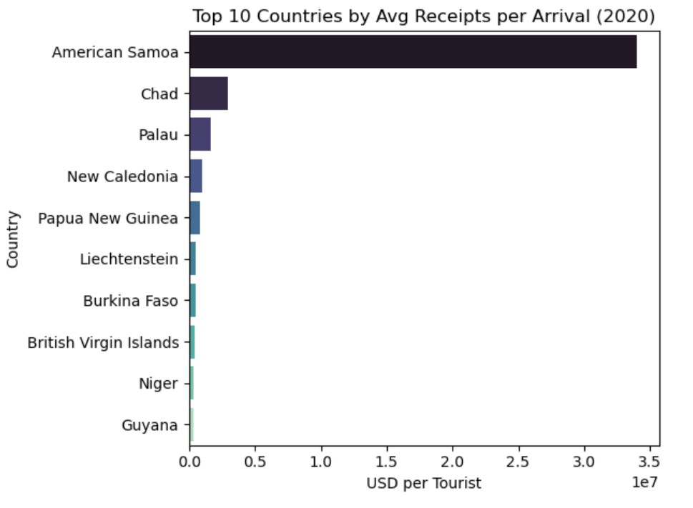
Insights:
- High Earners: Countries like Qatar, Luxembourg, and Switzerland lead in per-tourist revenue.
- Luxury Tourism: These nations attract fewer tourists but generate high income per visitor.
- Policy Implication: Focus on quality tourism can outperform mass tourism in economic returns.

ii. Tourism Receipts as % of GDP
Chart Type: Interactive Choropleth Map with Dropdown
Tool Used: Plotly Express
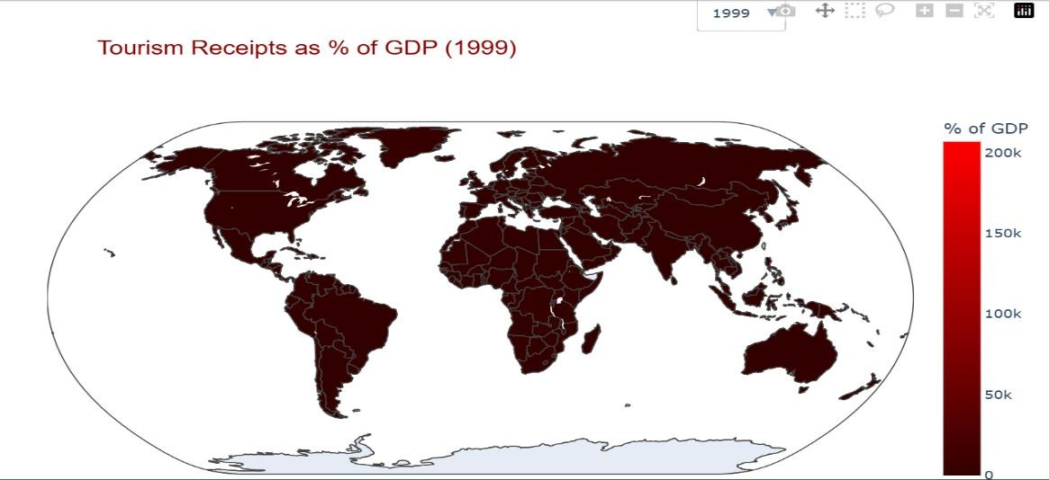
Insights:
- Tourism-Dependent Economies: Maldives, Seychelles, and Caribbean nations show >30% GDP reliance.
- Diversified Nations: Countries like USA, Germany, and Japan show <5% contribution.
- Strategic Use: Helps identify countries vulnerable to travel disruptions and prioritize resilience planning.

iii. Global Inflation and Unemployment Rates Over Time
Chart Type: Dual Line Plot
Tool Used: Matplotlib (Python)

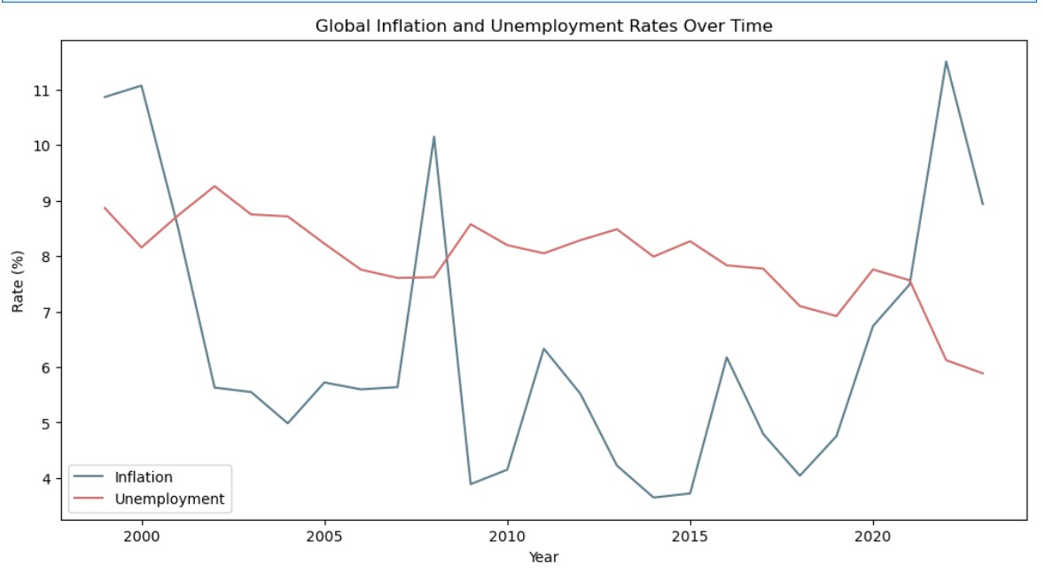

Insights
- 1990–2007: Both inflation and unemployment remained relatively stable, with inflation averaging ~3–4% and unemployment ~5–6%.
- 2008–2009 (Global Financial Crisis):
  - Inflation dipped due to demand collapse. o Unemployment spiked globally, especially in advanced economies.
- 2020 (COVID-19 Pandemic):
  - Inflation dropped sharply due to lockdowns and reduced consumer activity.
  - Unemployment rose to ~6.5% globally.
- 2022 (Post-COVID Spike):
  - Inflation peaked at ~7.9%, driven by supply chain disruptions and energy prices.
  - Unemployment began recovering but remained above prepandemic levels.

iv. Top 10 Country Groups by Tourist Arrivals (1999)
Chart Type: Horizontal Bar Chart
Tool Used: Plotly Express
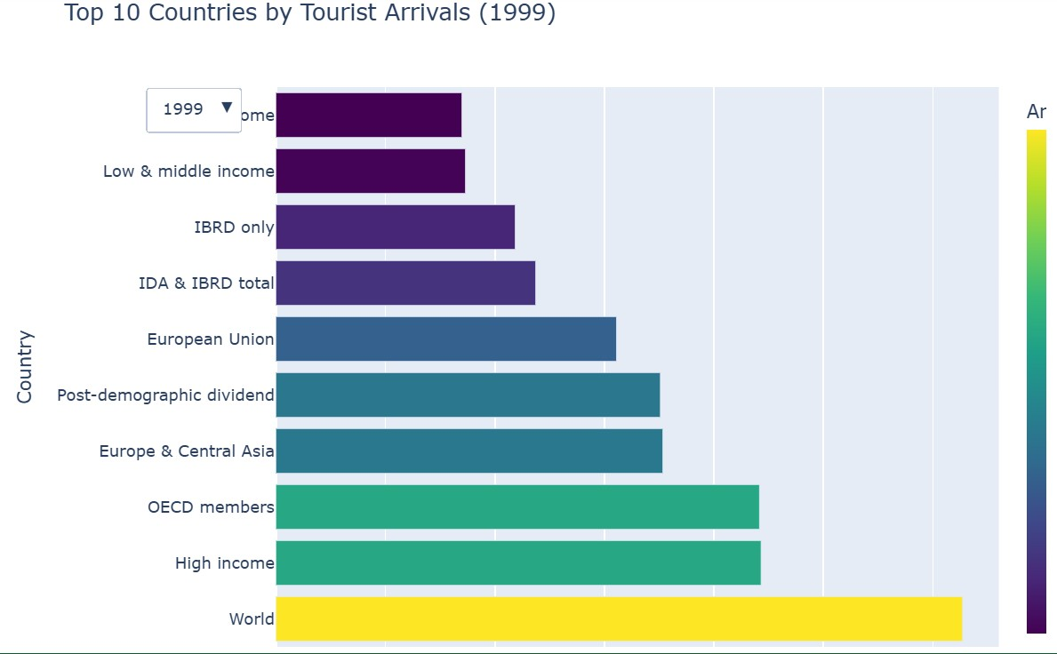
Insights:
- Global Dominance:
  - The “World” category has the highest number of tourist arrivals, serving as the aggregate benchmark for all regions.
- High-Income & OECD Nations Lead:
  - High income and OECD members show significantly higher tourist volumes, reflecting strong infrastructure, global connectivity, and established tourism industries.
- Regional Strength:
  - Europe & Central Asia and the European Union also rank high, indicating Europe’s historical dominance in global tourism.
- Developmental Divide:
  - Low income and Low & middle income groups show minimal tourist arrivals, highlighting disparities in tourism access, infrastructure, and global visibility.
v.GDP vs Tourism Receipts
Chart Name: Scatter Plot

Tool Used: Seaborn
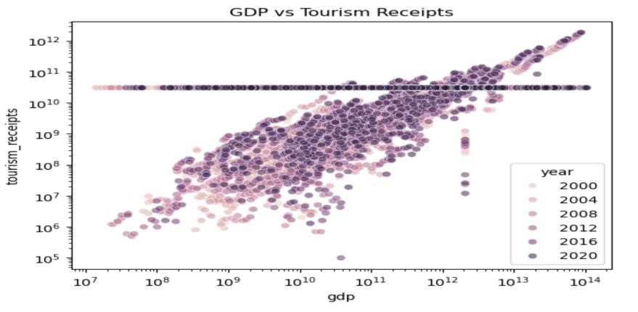
Insights:
- Log scale reveals clearer clustering and outliers across wide GDP and receipt ranges.
- Year-wise hue highlights temporal shifts in economic-tourism dynamics.
- High-GDP countries generally show higher tourism receipts, but some lower-GDP nations punch above their weight.
vi.Global Tourism Receipts Over Time
Chart Name: Line Chart

Tool Used: Matplotlib
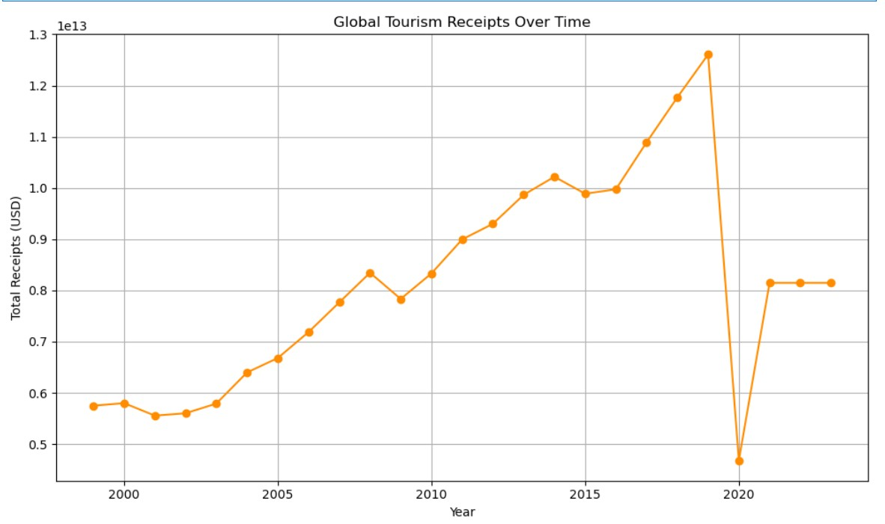
Insights:
- Global tourism receipts show a rising trend over the years, with occasional dips due to global disruptions.
- Sharp declines may reflect events like pandemics or economic recessions.
- Overall growth highlights tourism’s expanding role in the global economy.
vii.Tourism Receipts Growth Rate (%) by Country
Chart Name: Line Chart

Tool Used: Matplotlib
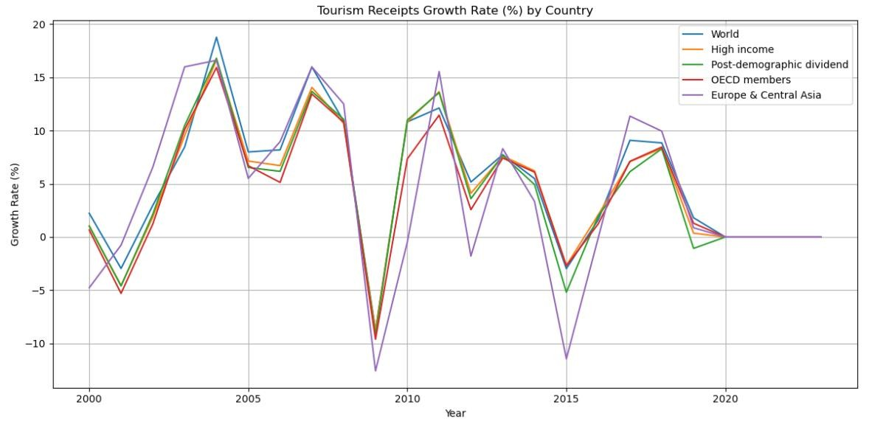
Insights:
- Top 5 countries show fluctuating year-on-year growth trends in tourism receipts.
- Sharp dips in certain years may reflect global events (e.g., pandemics, economic crises).
- Countries with consistent positive growth indicate strong tourism resilience and policy effectiveness

viii.Correlation Heatmap of Key Tourism and Economic Indicators
Chart Type: Correlation Heatmap

Tool Used: Seaborn
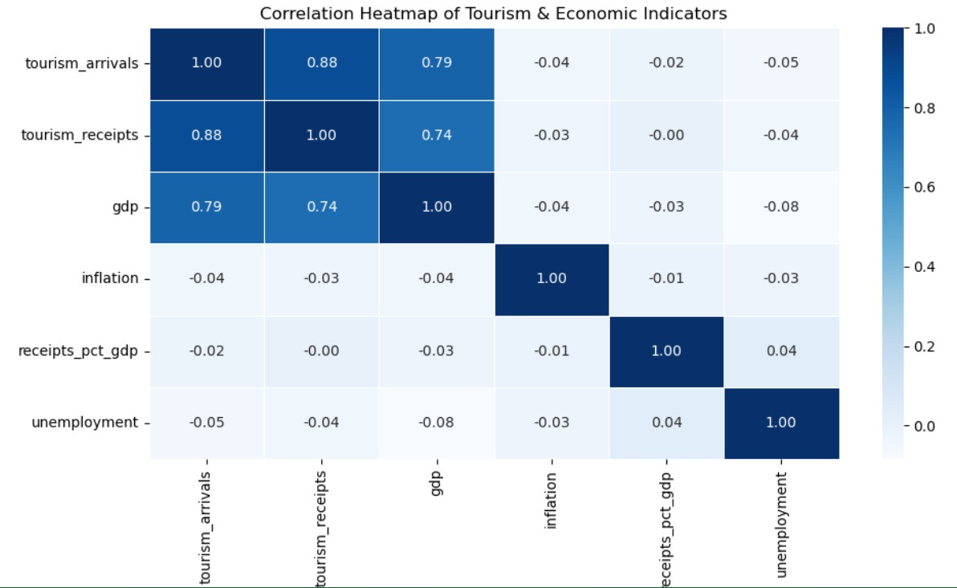
Insights:
- Strong positive correlation between tourism arrivals and receipts, indicating higher arrivals drive revenue.
- Moderate correlation between receipts_pct_gdp and tourism receipts, highlighting tourism’s economic impact.
- Weak or negative correlation between inflation and other indicators, suggesting limited direct influence ix.Tourism Expenditures vs. GDP

Chart Name: Scatter Plot Tool Used: Matplotlib
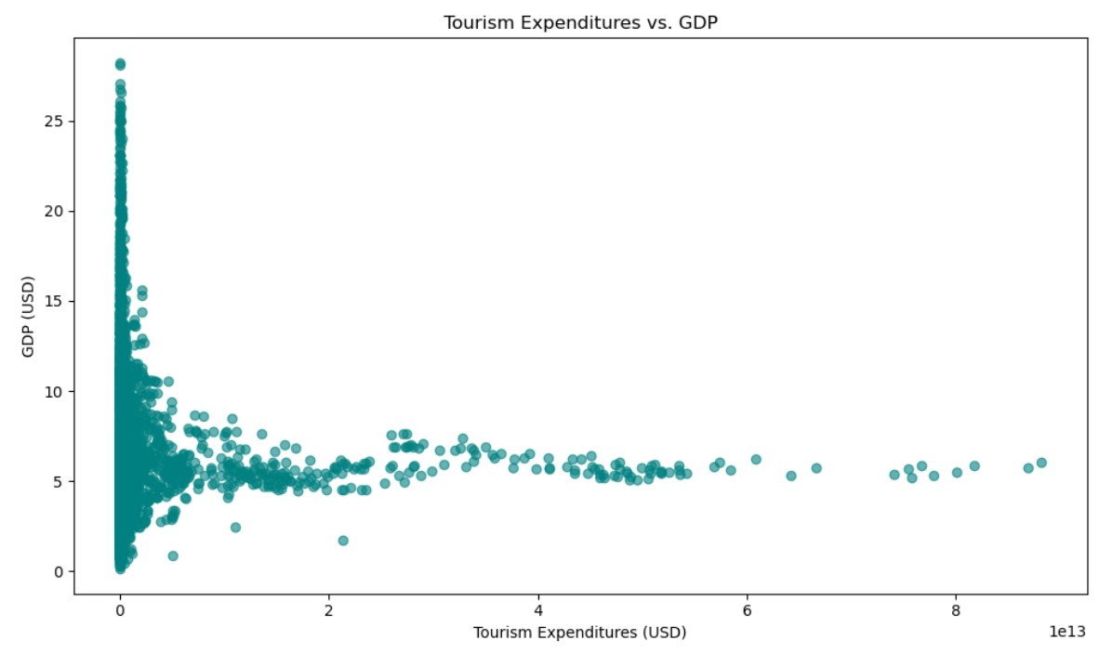
Insights:
- Positive correlation observed: countries with higher GDP tend to spend more on tourism.
- Outliers may indicate countries with disproportionately high or low tourism spending relative to GDP.
- Useful for identifying tourism-driven vs. diversified economies.

x.Distribution of Tourism Receipts
Chart Type: KDE Plot (Kernel Density Estimate)
Tool Used: Matplotlib
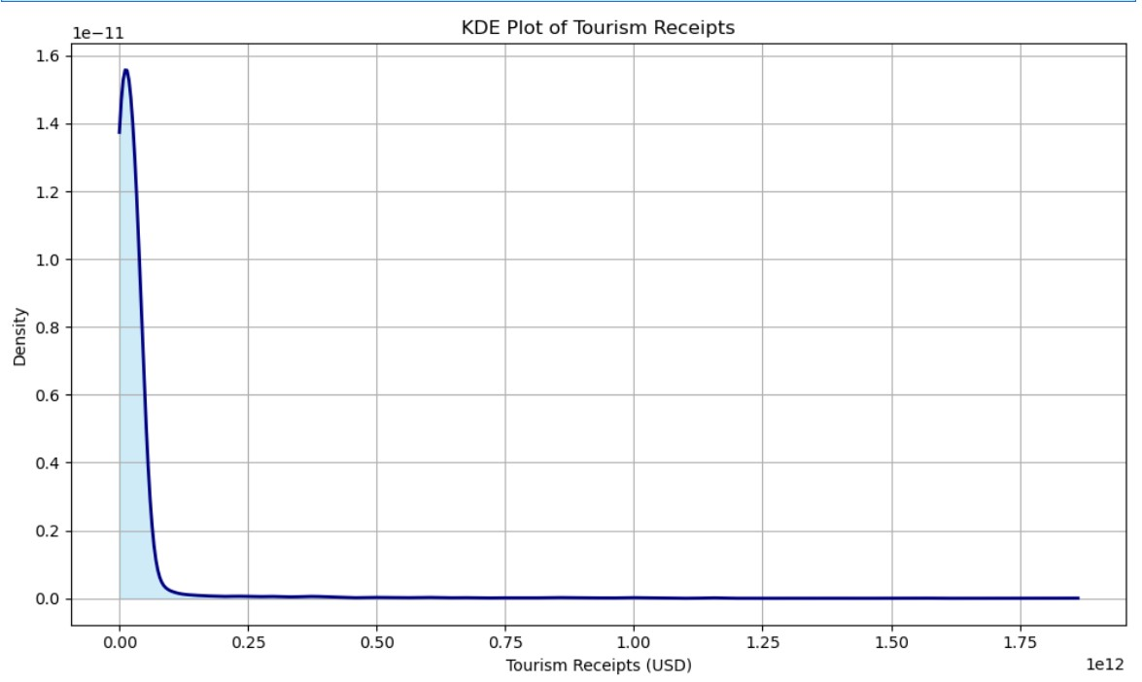
Insights:
- Most countries cluster around lower tourism receipt values.
- A long right tail indicates a few countries earn exceptionally high receipts.
- Smooth distribution helps identify skewness and outliers in global tourism income

9. Insights Generation
- Countries like Qatar and Luxembourg lead in receipts per tourist.
- Island nations show high tourism dependency (>30% of GDP).
- Post-2020 recovery varies by region—Asia and Europe rebounding faster.
- Receipts per arrival is a strong indicator of tourism quality, not just quantity.

10. Conclusion
This analysis reveals the economic significance of tourism and its uneven global distribution. By combining financial metrics with geographic visualization, the report offers a compelling narrative for understanding global tourism dynamics. The insights can guide tourism boards, investors, and policymakers in strategic decision-making

